Policy
Policy Category: Health and Safety
Date Created – 6 April 2016
Policy Name: Child Protection

Child Protection Policy

Rational:
Little Pioneers is committed to the prevention of neglect, physical, verbal, emotional and sexual abuse and the protection of children. This commitment means that the interests and welfare of the child are the prime considerations when any decision is made about suspected abuse.
Child abuse and neglect is not acceptable. Children need our protection. Where protection is not adequately provided by the adults responsible for the child, others need to step in to ensure the child receives adequate protection.
The safety and wellbeing of the child is our top priority when investigating suspected or alleged abuse.
We support the roles of the New Zealand Police (the Police) and te oranga tamariki in the investigation of suspected abuse and will report suspected/alleged abuse to these agencies.
We are committed to giving support to families. We are aware of agencies in the community who will give support and counsel to families.
LP (Little Pioneers) will ensure that a training session for staff on suspecting child abuse will be held biannually. New staff and volunteers will be made familiar with our child protection procedures (which will be included in the Information Folder for new staff).
Management will make sure each staff member is familiar with the te oranga tamariki-‘Let’s stop child abuse together.’-which outlines what constitutes child abuse and neglect. The centre will watch for behaviour, play and language that cause concern. We will keep records of any likely indications of abuse. Records and observations (date, time, signs e.g. bruises, language, etc) will be kept in the office filing cabinet, noted on an incident report form. Each report form shall be countersigned.
The purpose of this operational policy is to ensure that there is a procedure for responding to suspected child abuse and in so doing meeting Licensing Criteria HS31 and provisions of the Vulnerable Children Act 2014.
For the purpose of this policy, abuse is used in the context of adult to child. This could be staff to child or an adult (outside of the centre) to the child.
Abuse relating to child to child or child to adult is not within the scope of this policy.
Te Whariki:
Well-being- Goal 1. The health and well-being of the child are protected and nurtured

Issue Outline
Not all children have the support and protection of a trusted adult.
Children that are abused or neglected need adults that can act on their behalf and keep them safe from harm.
Adults who care for children need to know how to respond to a child if the child discloses abuse or when there are concerns raised from others about abuse or neglect.
Definitions
Child Abuse is defined in the te oranga tamarikias “the harming (whether physically, emotionally, or sexually), ill-treatment, abuse, neglect or deprivation of any child or young person.”
- Child Abuse can be:
- Physical Abuse
- Emotional Abuse
- Sexual Abuse
- Neglect
Neglect “is a pattern of behaviour which occurs over a period of time and results in impaired functioning or development of a child. It is the failure to provide for a child’s basic needs.
Neglect may be:
- Physical - failure to provide necessary basic needs of food, shelter or warmth
- Medical - failure to seek, obtain or follow through with medical care for the child
- Abandonment - leaving a child young person in any situation without arranging necessary care for them and with no intention of returning
- Neglectful supervision – failure to provide developmentally appropriate or legally required supervision
- Refusal to assume parental responsibility - unwillingness or inability to provide appropriate care for a child.”
From Child Matters website: www.childmatters.org.nz

Policy principles
The interest and protection of the child is paramount in all actions.
We recognise the rights of family/Whānau to participate in the decision-making about their children.
We have a commitment to ensure that all staff are able to take appropriate action in response to suspected abuse situations.
We will always comply with relevant legislative responsibilities.
We are committed to share information in a timely way and to discuss any concerns about an individual child with colleagues or the Centre Manager.
We are committed to promote a culture where staff feel confident that they can raise issues of concern without fear of reprisal.

Detail

Signs of abuse and neglect
Signs that a child’s safety and wellbeing is in danger include:
- child tells someone they have been abused (eg, have been hit, touched or are frightened)
- baby or child with unexplained or untreated injuries
- anxiety, fear or aggression
Our centre will take urgent action if there are signs of abuse and neglect. We tell staff and parents to trust their instincts and act immediately. We will follow the ‘Child Abuse Process’ (attached).
Indicators of potential abuse:
- Physical signs – unexplained injuries, burns, fractures, unusual or excessive itching, genital injuries, sexually transmitted diseases.
- Developmental delays – e.g. for their age, cognitive delays, falling behind in milestones, poor speech and social skills)
- Emotional abuse/neglect – e.g. sleep problems, low self-esteem, obsessive behaviour, inability to cope in social situations, sadness/loneliness and evident self harm.
- Behavioural concerns - e.g. age-inappropriate sexual interest or play, fear of a certain person or place, eating disorders, disengagement/neediness, aggression.
- Neglect – e.g. Physical signs (looking rough and uncared for, dirty, without appropriate clothing, underweight).
- Medical neglect – e.g. persistent nappy rash, or skin disorders or other untreated medical issues.
- Child talking about things that indicate abuse (sometimes called an allegation or disclosure).

Allegations or concerns about staff
When a staff member is suspected, the same processes apply.

Confidentiality and information sharing
The Privacy Act 1993 and the te oranga tamariki Children, Young Persons, and their Families Act 1989 allow information to be shared to keep children safe when abuse or suspected abuse is reported or investigated. Note that under sections 15 and 16 of the te oranga tamariki Act, any person who believes that a child has been, or is likely to be, harmed physically, emotionally or sexually or ill-treated, abused, neglected or deprived may report the matter to te oranga tamariki or the Police and, provided the report is made in good faith, no civil, criminal or disciplinary proceedings may be brought against them.

The Manager will:
- Always prioritise the safety and wellbeing of the child.
- Maintain confidentiality. Failure of staff to comply with this policy will be regarded as serious misconduct.
- Respect the rights of those involved during any investigation.
- Immediately investigate and fully and objectively record in writing, any reports of incidents, allegations or suspicions of child abuse. The Manager will, where appropriate, seek the assistance of the Ministry of Education, te oranga tamariki, Policy and/or other professional agencies in order to conduct a full investigation.
- Report child abuse to the Police or te oranga tamariki (see Process for Reporting Child Abuse attached)
- Inform parents after discussing the best way to do this with Police or te oranga tamariki advisors. If a family member of close associate of the family or whanāu is suspected of child abuse, the parent(s) may not initially be informed, but the centre will ensure that the information is disclosed by an appropriate person at an appropriate time.
- Suspend a staff member under suspicion until a full investigation can be completed.
- Maintain appropriate records.
- Ensure the centre’s procedures protect staff from unjustified allegations of abuse.
- Ensure the centre has educational and informational resources for children and adults on child abuse.

Staff will:
- Always prioritise the safety and wellbeing of the child.
- Familiarise themselves with this centre policy.
- Immediately notify the Manager if they observe signs of child abuse or anyone reports to them any suspicions of child abuse of children at the centre, or a pattern of neglect or concerns is identified.
- Maintain confidentiality. Failure of staff to comply with this policy will be regarded as serious misconduct.

Protected Disclosure
When a staff member or associate brings a case of child abuse to the attention of the center or the authorities, our centre will not disclose the name of the person without their permission unless it is to te oranga tamariki or the Police and is necessary to do so in the interests of the child.

Alignment with Other Policies
- Personnel policies – police checks and careful employment of temporary staff, casual staff, friends of friends, volunteers
- Outings and excursions policy
- Information & Complaints policy
- Child Protection Policy

Relevant Background (including legislation/regulation references)
Regulation 46 Health and Safety Practices standard: general (1) of the Education (Early Childhood Services) Regulations 2008
Licensing Criteria for Early Childhood Education and Care Centres 2008
Child Protection
Health and safety practices criterion 31
A process for the prevention of child abuse is implemented, and a procedure for responding to suspected child abuse is followed when required.
Health and Safety practices criterion 32
All practicable steps are taken to protect children from exposure to inappropriate material (for example, of an explicitly sexual or violent nature).
See Ministry of Education child abuse information on:
http://www.education.govt.nz/assets/Documents/School/Traumatic-incidents-and-emergencies/MoE-STA-CYFProtocolForReportingActualOrSuspectedChildAbuseNov09Amendment-3-2015.pdf
Vulnerable Children Act 2014 and associated regulations.

Impacts of Policy on Staff, Parents, Children
Clear procedures will strengthen the ability of staff, parents, and other agencies to adequately respond to signs of abuse and or neglect.

Alignment with the Centre Philosophy
This policy is aligned with the centre’s philosophy.

Implications and/or Risks
Failure to correctly identify and respond to abuse and or neglect can be harmful to the wellbeing of the child and their family/whanau. It will also seriously damage the reputation of the centre, its staff and the reputation of early childhood centres.

Implementation

We build discussions into enrolment procedures and staff trainings/meetings.

Responding to a child when the child discloses abuse
- Listen to the child | Disclosures by children are often subtle and need to be handled with particular care, including an awareness of the child’s cultural identity and how that affects interpretation of their behaviour and language.
- Reassure the child | Let the child know that they:  - Are not in trouble  - Have done the right thing
- Ask open-ended prompts – eg: “what happened next?” | Do not interview the child in other words, do not ask questions beyond open prompts for the child to continue)  Do not make promises that cannot be kept, eg: “I will keep you safe now”
- If the child is visibly distressed | Provide appropriate reassurance and re-engage in appropriate activities under supervision until they are able to participate in ordinary activities
- If the child is not in immediate danger | Re-involve the child in ordinary activities and explain what you are going to do next
- If the child is in immediate danger | Contact the Police immediately (call 111)
- As soon as possible, formally record the disclosure | Record:  - Word-for-word what the child said  - The date, time and who was present

Recording and notifying te oranga tamariki of suspected child abuse or neglect
What process to follow | For example | Key considerations
- Recording | Formally record:  - Anything said by the child  - The date, time, location and the names of any staff that may be relevant  - The factual concerns or observations that have led to the suspicion of abuse or neglect (eg: any physical, behavioural or developmental concerns)  - The action taken by your centre  - Any other information that may be relevant | Relevant information can inform any future actions
- Decision-making | Discuss any concern with the centre manager/supervising teacher or designated person for child protection | No decisions should be made in isolation
- Notifying authorities | Notify te oranga tamariki promptly if there is a belief that a child has been or is likely to be abused or neglected.  A phone call to the National Contact Centre (0508 Family / 0508 326459) is the preferential initial contact with te oranga tamariki as this enables both parties to discuss the nature of the concerns and appropriate response options.  Phone: 0508 Family / 0508 326459  Fax: 09 914 1211  e-mail: contact@ot.govt.nz | te oranga tamariki will:  - Make the decision to inform the parents or caregivers in consultation with your centre  - Advise what, if any, immediate action may be appropriate, including referring the concern to the Police
- Following the advice of Te Oranga Tamariki | te oranga tamariki advice will include what, if any, immediate action may be appropriate, including referring the concern to the Police | te oranga tamariki is responsible for looking into the situation to find out what may be happening, whether they need to work with the family or to put them in touch with people in their community who can help
- Storing relevant information | Securely store:  - The record of the concern  - A record of any related discussions, including copies of correspondence where appropriate  - A record of any advice received  - The action your centre took, including any rationale  - This concern with any earlier concerns, if the notification is based on an accumulation of concerns rather than a specific incident | Records assist in identifying patterns

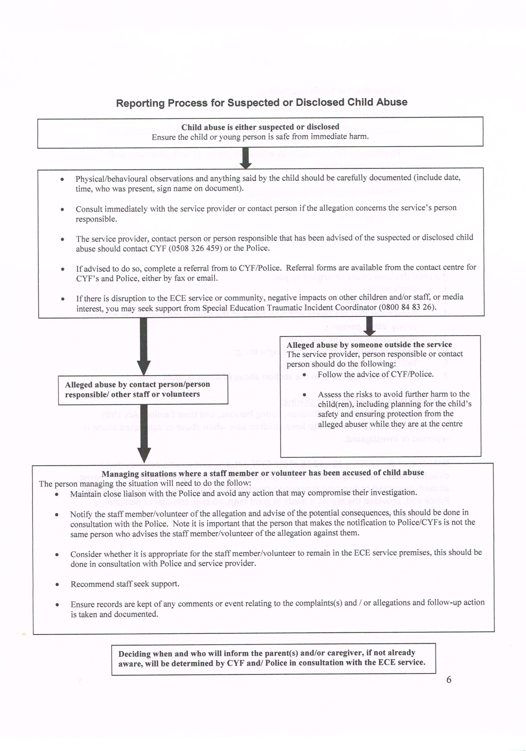
Completed Feb 2016 Completed Jan 2016
Reviewed January 2017 Reviewed March 2018
Reviewed annually
Sign: Emma Reichenbach

Section 2, te oranga tamariki 1989.

